Activities are subject to change.  C = Centrum  CL = Cedar Lake  P = Promenade  LL = Lower Level Craft Room  TBD = To Be Determined |  |  | 9:45-11 Crossword Puzzles  9:45-11 Daily Chronicles  1-2:30 Flower Art  2:00 BINGO – D3 | 10:00 Exercise on the Promenade – P  1-2 Afternoon Rounds with Jessica  3:15 Music with Lori Dokken – P | 10:30 Buddy Walks - CL  1:30-3:30 Self-Portrait Workshop – C | 9:45-11 Friday Morning Funnies  9:45-11 Morning Chats  1:30 Afternoon Concert: Chris, Guitar - C | TR staff out of building  9:30-11:00 Sensory Items  2:00 Netflix Movie Matinee – Unit Dining Rooms
10:00 Sunday Worship Service – C  2:30 Traveling Aromatherapy & Hand Massages | 9:45-11 Monday Morning Movement  9:45-11 Sensory Morning  1-2:30 Manicures  1:30-3:30 Self-Portrait Workshop – C | 9:45 – 11 Silly Stories 101 Pt. 2  9:45-11 Craft Time  1-2:30 Daily Chronicles  2:00 BINGO – D3 |  | 10:00 Exercise on the Promenade – P  1-2 Afternoon Rounds with Jessica  3:15 Music with Lori Dokken – P | 10:30 Buddy Walks - CL  1-2:30 Afternoon Reminisce | 9:45-11 Music Morning  9:45-11 Morning Stretch  2:00 Movie Matinee with Popcorn – Unit Dining Rms | 8:45 – 10 Sunny Side of the Bed  Mail Delivery 1:1 Rounds  3-4 Saturday Surprise
10:00 Sunday Worship Service – C  2:30 Father’s Day Themed Word Games | 9:45 – 11 Monday  Morning Movement - P  1-2:30 Afternoon Chats  1:30-3:30 Self-Portrait Workshop – C | 9:45 – 11 Morning Stretch  9:45-11 Humor Time  1-2:30 Short Stories  2:00 BINGO – D3 |  | 10:00 Chaplain Chats – P  11:15 Dine-In: Yum! Bakery - C  1-2 Afternoon Rounds with Jessica  3:15 Music with Lori Dokken – P | 10:30 Buddy Walks - CL  1-1:45 Travel Reminisce  1:45 Traveling Cart: Father’s Day Root Beer Floats | 9:45-11 Sensory Reminisice  1:45 Movie Matinee with Snacks – C | TR staff out of building  9:30-11:00 Sensory Items  2:00 Netflix Movie Matinee – Unit Dining Rooms
10:00 Sunday Worship Service – C  2:30 Sunshine Social | 9:45-11 Summer Stirrings  9:45-11 Garden Sensory  1-2:30 Afternoon Hand Massages  1:30-3:00 Self-Portrait Celebration – TBD | 9:45 –11 Daily Chronicle  9:45-11 Craft Time  1-2:30 Active Afternoon  2:00 BINGO – D3 |  | 10:00 Chaplain Chats – P  1-2 Afternoon Rounds with Jessica  3:15 Music with Lori Dokken – P | 10:30 Buddy Walks – CL  1-2:30 Time Slips | 9:45-11 Musical Morning  9:45-11 Creative Coloring  1:30 Afternoon Concert: Chris, Guitar - C | 8:45 Morning Greetings  – 10  Mail Delivery 1:1 Rounds  3-4 Traveling Trivia
10:00 Sunday Worship Service – C  2:30 Traveling Daily Chronicle Reading and Chats | 9:45-11 Chat Pack  9:45-11 Nature Study  “Forest Friends”  1:00-2:30 Traveling  Chaplain Chats | 9:45 – 11 MN Lakes  9:45-11 Short Stories  1-2:30 Sensory Rounds  2:00 BINGO – D3 |  | 10:00 Exercise on the Promenade - P  1-2 Afternoon Rounds with Jessica  3:15 Music with Lori Dokken – P | 2nd Floor Activity Calendar
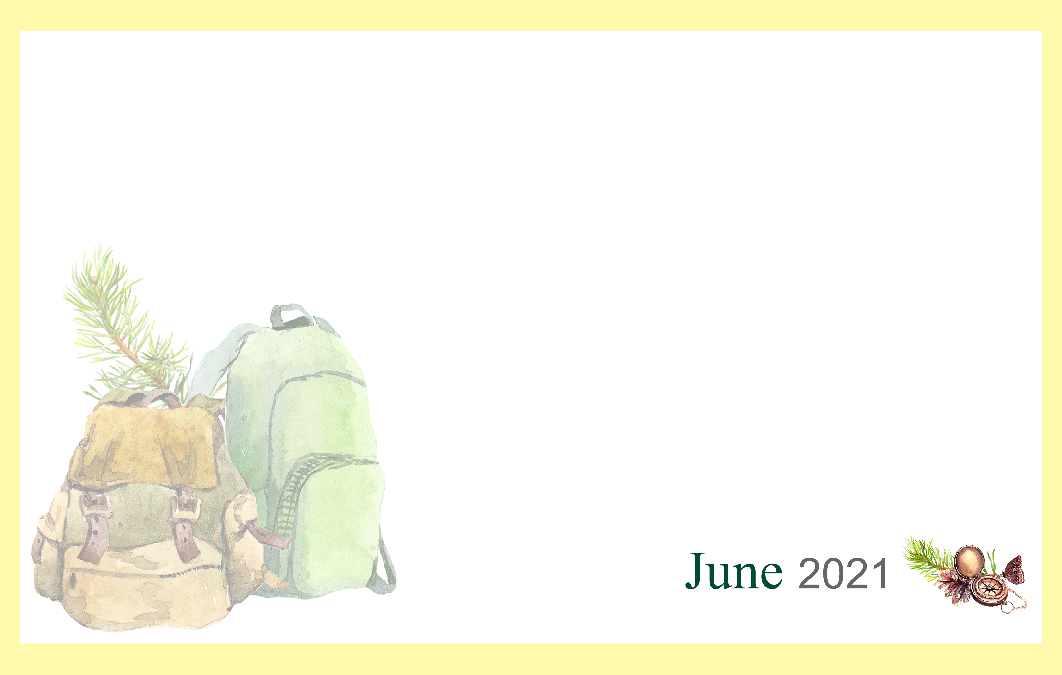
Sunday | Monday | Tuesday | Wednesday | Thursday | Friday | Saturday
 |  | 1 | 2 | 3 | 4 | 5
6 | 7 | 8 | 9 | 10 | 11 | 12
13 | 14  Flag Day (US) | 15 | 16 | 17 | 18 | 19  Juneteenth
20  Summer Begins  Father’s Day | 21 | 22 | 23 | 24 | 25 | 26
27 | 28 | 29 | 30

